Night of
Worship and Praise
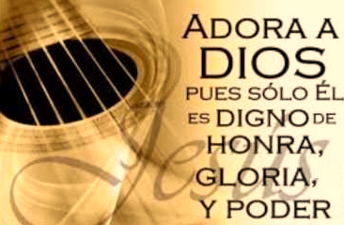
The Hispanic community of St. Francis De Sales invites you to a
Night of Worship and Praise
November 19, 2016
Hour: 7:00pm
Place: Worship Center
1409 Abingdon Rd. Abingdon, MD 21009

For information: Daniel Velez, Daniel Cajigas
Email: velez0126@hotmail.com

