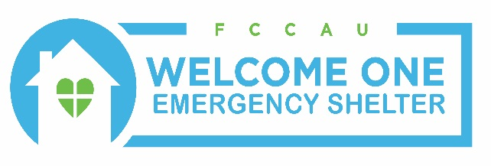
1221 C Brass Mill Road Belcamp, MD 21014
410-272-2229 phone 410-229-2346 fax welcomeoneshelter.com

March 12, 2019

Dear Supporter and Friend of Welcome One,

St. Francis de Sales Church’s Confirmation Class of 2020 is sponsoring a 5K Race to benefit Welcome One Emergency Shelter. Welcome One Emergency Shelter is Harford County’s only year-round emergency shelter for men and women experiencing Homelessness in Harford County. Would you consider investing in those less fortunate in our community by supporting this event?

We invite you to join us in our mission of assisting and empowering individuals who are committed to self-sufficiency and a more independent life. Your partnership will assist us in making this 5K invitational a success that will allow us to continue our mission and change the lives of those less fortunate than ourselves.

We appreciate your support and friendship; you make it possible for Welcome One to provide shelter, clothing, three meals daily, laundry and shower facilities for over 140 individuals every year. Most importantly we offer case management services to help our residents find their way to community housing. Welcome One is a 501 (c) 3 organization and our tax-exempt number is 52-2341599. All donations are tax deductible to the full extent of the law.

Thank you for considering our request as we partner together to make a difference in the lives of others,

Liz Tutino
Executive Director

