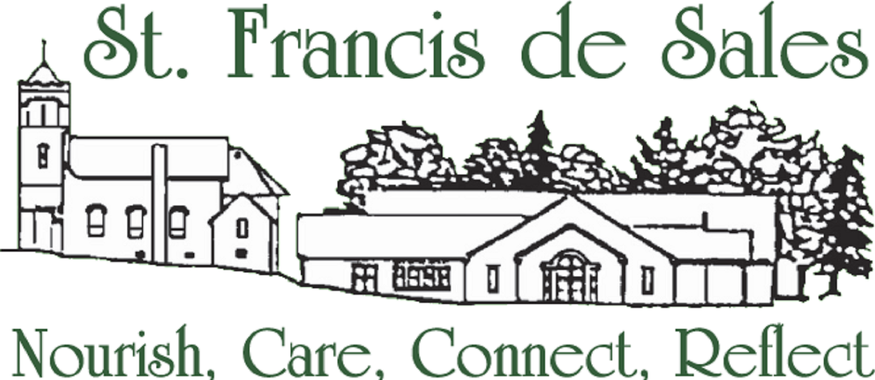

1450 Abingdon Road
Abingdon, MD 21009
Fed. Id # 52-0805022 September 1, 2018

Community Friend:

The 2019 Confirmation Candidates at St Francis de Sales parish is sponsoring and promoting a 5K race/1mile walk titled Called to Serve: Anna’s House, to benefit Anna’s House located in Harford County Maryland. Anna’s House provides a broad array of homeless services including emergency shelter for families, transitional housing for families fleeing domestic violence, permanent supportive housing and rapid re-housing.
WE NEED YOUR SUPPORT! We cannot do this alone, our success on this undertaking will rely greatly on the generosity of the community businesses.
You can help by
- Registering a team to run or walk the course. Better yet, challenge another business!
- Donating gift cards or items from your business to offer as raffle items for our runners/walkers.
- Becoming a sponsor (checks payable to St. Francis de Sales Church)
  - Title Sponsor $1,000
  - Gold Sponsor $750
  - Silver Sponsor $500
  - Bronze Sponsor $250
  - Partner Sponsor $100
  - Family & Friends $1-$99
We are a 501(c) (3) organization and your gift is tax deductible! In return for your generous donation or sponsorship, you will be recognized as a community partner of race.

We greatly appreciate your time and kind consideration of our request. All support is appreciated. If you have questions or concerns, please direct it to the attention of Diane Lewis at the address listed above, or use the email/phone number listed below.

Sincerely,
Diane Lewis, Youth Minister
Diane.Lewis@archbalt.org
443-253-8775

